4909-50 St. Box 270
Valleyview, AB T0H 3N0
 780-524-5150
 780-524-2727
info@valleyview.ca

TOWN RESIDENTIAL LOTS FOR SALE:
(Updated April. 24, 2023)

Civic Address | Plan | Block | Lot
5315 – 42nd Street | 0522881 | 1 | 1
5313 – 42nd Street |  |  | 2
5311 – 42nd Street |  |  | 3
5307 – 42nd Street |  |  | 5
5315 – 42nd Street | 0522881 | 1 | 1
5313 – 42nd Street |  |  | 2
5311 – 42nd Street |  |  | 3
*Price per lot: $35,000.00 + GST. (Includes paving, no Local Improvement Levy)
*Zoning: Restricted Residential (R1) District. (Land Use Bylaw #2016-08)
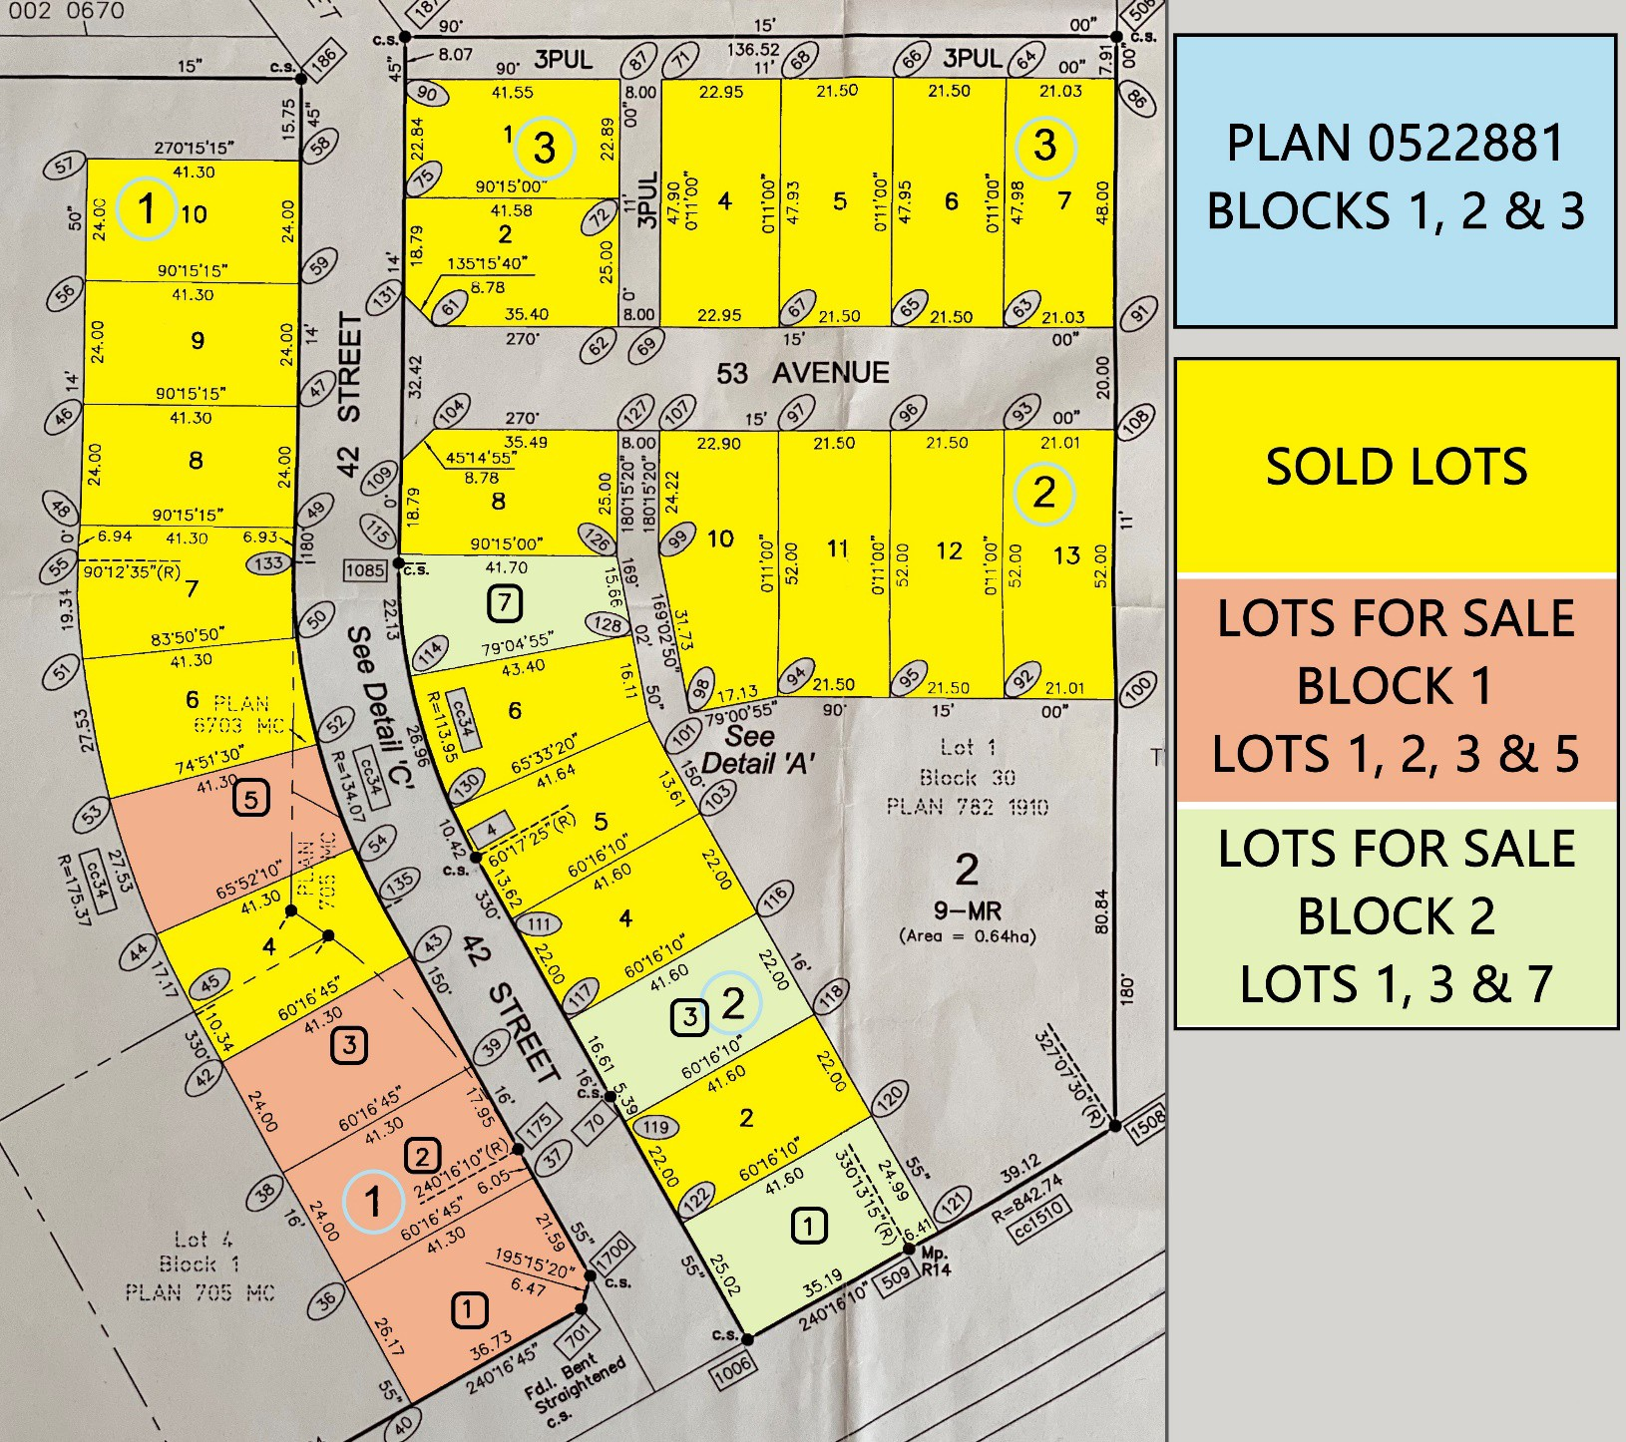

DEVELOPMENT & PLANNING
https://valleyview.ca/development-planning/

4909-50 St. Box 270
Valleyview, AB T0H 3N0
 780-524-5150
 780-524-2727
info@valleyview.ca

LAND USE BYLAW #2022-11 EXCERPT.
Section B4.1 Restricted Residential (RR) District
Purpose | The purpose of this Land Use District is to provide for low density residential development in the form of Single Detached Dwellings with provisions for Duplex dwellings and complementary uses.
Uses
a) Permitted Uses | - single detached dwelling  - accessory building or use  - Home-Based Business, Minor
b) Discretionary Uses | - Accessory Building or Use to a Discretionary Use  - Bed and Breakfast  - Duplex  - Family Day Home  - Home-Based Business, Major  - Solar Collector  - public use
Site Provisions | In addition to the General Regulations contained in Part C, the following standards shall apply to every development in this district.
Lot Area (minimum): | 465 m² (5,000 ft2)
Lot Width (minimum): | 15 m (50 ft.)
Front Yard Setback (minimum): | 6.1 m (20 ft.)
Rear Yard Setback (minimum): | 4.6 m (15 ft.)
Side Yard Setback, Exterior (minimum): | 3.0 m (10 ft.),
Side Yard Setback, Interior (minimum) | 1.5m (5 ft), In a subdivision with no lane, one (1) side yard shall be a minimum of 3m (10 ft) to provide for vehicular access to rear yard unless attached Garage provided.
Building Height  (maximum): | 8.2 m (27 ft.) for principal building  4.6 m (15 ft.) for accessory building
Site Coverage  (maximum): | 35 percent
Other Regulations | Refer to General Regulations contained in Section C.1 for other  requirements that may apply.

DEVELOPMENT & PLANNING
https://valleyview.ca/development-planning/

